OOP Lab Assignment 1
Yashas Kamath, 200905132, Sec D
1.a. Write a method isPrime to accept one integer parameter and to check whether that parameter is prime or not.
b. Using this method, generate first N prime numbers in the main method.
The Scanner class isn’t working on my system and hence I have hard-coded my program.
class Prime{
boolean isPrime(int x){
if(x==1)
return false;
if(x==2||x==3)
return true;
for(int i=2;i<=x/2;i++){
if(x%i==0)
return false;
}
return true;
}
}
public class Program1{
public static void main(String[] args){
int N=50;
Prime p=new Prime();;
System.out.println("The series of prime numbers from 1 to "+N+":");
for(int i=1;i<=N;i++){
if(p.isPrime(i))
System.out.print(i+" ");
}
}
} Output:
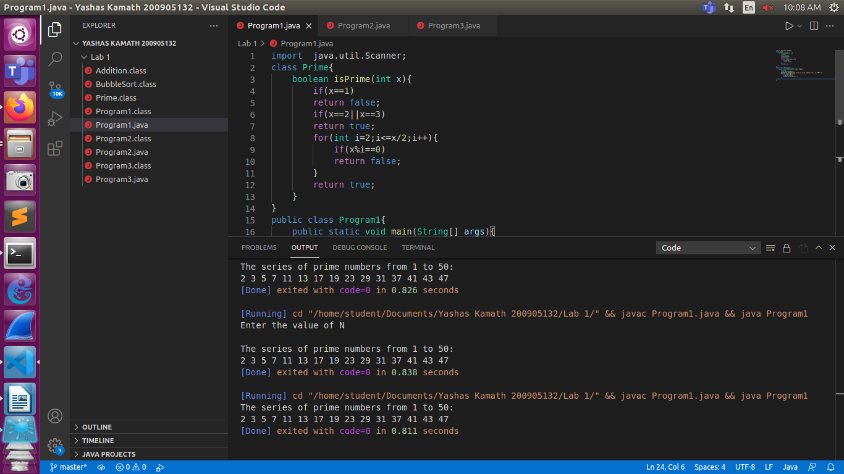
2. Arrange the elements in ascending and descending order using Bubble sort method.
class BubbleSort{
void ascending(int arr[]){
for(int i=0;i<arr.length-1;i++)
for(int j=0;j<arr.length-1-i;j++)
if(arr[j]>arr[j+1])
{
int temp=arr[j];
arr[j]=arr[j+1];
arr[j+1]=temp;
}
}
void descending(int arr[]){
for(int i=0;i<arr.length-1;i++)
for(int j=0;j<arr.length-1-i;j++)
if(arr[j]<arr[j+1])
{
int temp=arr[j];
arr[j]=arr[j+1];
arr[j+1]=temp;
}
}
}
public class Program2{
public static void main(String[] args){
int arr[]={3,4,1,8,9,2,0,7,6,5};
BubbleSort b=new BubbleSort();
b.ascending(arr);
System.out.println("The ascending order of the array is ");
for(int i=0;i<arr.length;i++)
System.out.print(arr[i]+" ");
System.out.println("\nThe descending order of the array is ");
b.descending(arr);
for(int i=0;i<arr.length;i++)
System.out.print(arr[i]+" ");
}
}
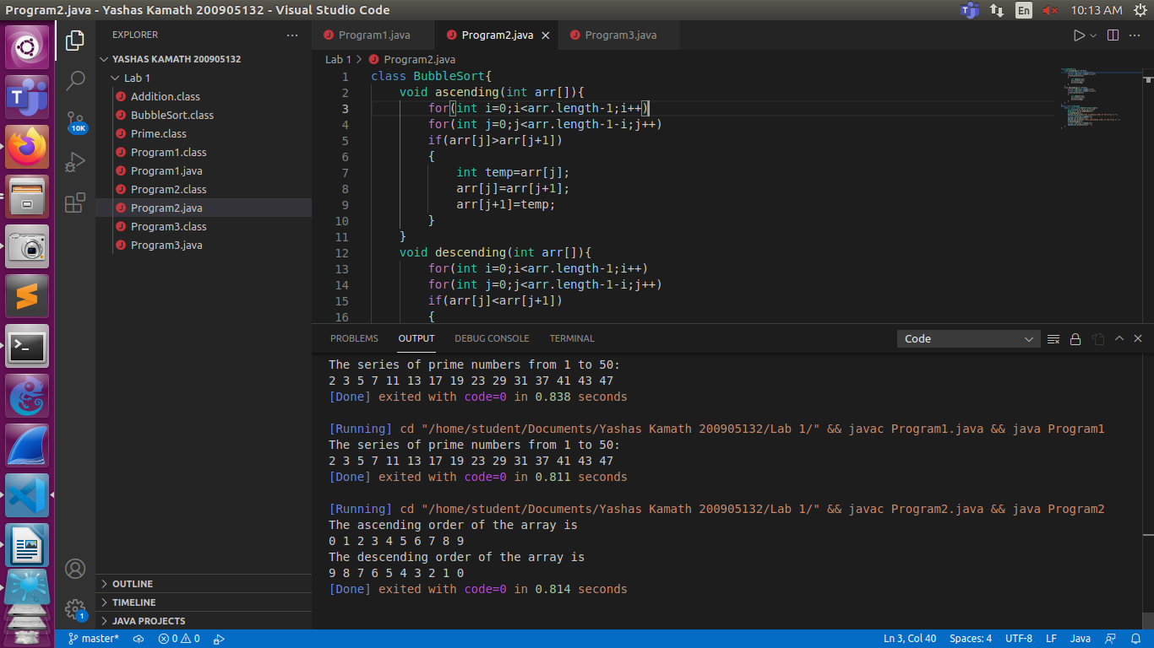

3.Find the addition of two matrices and display the resultant matrix.
class Addition{
void sum(int a[][],int b[][],int c[][]){
for(int i=0;i<a.length;i++)
for(int j=0;j<a[i].length;j++)
c[i][j]=a[i][j]+b[i][j];
}
public class Program3{
public static void main(String[] args){
int a[][]={{1,2,3},{4,5,6}};
int b[][]={{9,10,11},{12,13,14}};
int c[][]=new int[2][3];
Addition add=new Addition();
add.sum(a,b,c);
System.out.println("The sum of the 2 arrays is ");
for(int i=0;i<c.length;i++){
for(int j=0;j<c[i].length;j++)
System.out.print(c[i][j]+" ");
System.out.println();
}
}
}
